Spring Data JPA HandsOn
Spring Data JPA - Quick Example
Country.java:
package com.cognizant.ormlearn.model;

import javax.persistence.Column;
import javax.persistence.Entity;
import javax.persistence.Id;
import javax.persistence.Table;

@Entity
@Table(name = "country")
public class Country {

@Id
@Column(name = "co_code")
private String code;

@Column(name = "co_name")
private String name;

public String getCode() {
return code;
}

public void setCode(String code) {
this.code = code;
}

public String getName() {
return name;
}

public void setName(String name) {
this.name = name;
}

@Override
public String toString() {
return "Country [code=" + code + ", name=" + name + "]";
}
}

CountryRepository.java:
package com.cognizant.ormlearn.repository;

import org.springframework.data.jpa.repository.JpaRepository;
import org.springframework.stereotype.Repository;
import com.cognizant.ormlearn.model.Country;

@Repository
public interface CountryRepository extends JpaRepository<Country, String> {
}
CountryService.java:
package com.cognizant.ormlearn.service;

import java.util.List;
import javax.transaction.Transactional;
import org.springframework.beans.factory.annotation.Autowired;
import org.springframework.stereotype.Service;
import com.cognizant.ormlearn.model.Country;
import com.cognizant.ormlearn.repository.CountryRepository;

@Service
public class CountryService {

@Autowired
private CountryRepository countryRepository;

@Transactional
public List<Country> getAllCountries() {
return countryRepository.findAll();
}
}

OrmLearnApplication.java (Main App):
package com.cognizant.ormlearn;

import java.util.List;
import org.slf4j.Logger;
import org.slf4j.LoggerFactory;

import org.springframework.boot.SpringApplication;
import org.springframework.boot.autoconfigure.SpringBootApplication;
import org.springframework.context.ApplicationContext;

import com.cognizant.ormlearn.model.Country;
import com.cognizant.ormlearn.service.CountryService;

@SpringBootApplication
public class OrmLearnApplication {

private static final Logger LOGGER = LoggerFactory.getLogger(OrmLearnApplication.class);

private static CountryService countryService;

public static void main(String[] args) {
ApplicationContext context = SpringApplication.run(OrmLearnApplication.class, args);
countryService = context.getBean(CountryService.class);

testGetAllCountries();
}

private static void testGetAllCountries() {
LOGGER.info("Start");
List<Country> countries = countryService.getAllCountries();
LOGGER.debug("countries={}", countries);
LOGGER.info("End");
}
}
MySQL Table:
CREATE SCHEMA ormlearn;

USE ormlearn;

CREATE TABLE country (
co_code VARCHAR(2) PRIMARY KEY,
co_name VARCHAR(50)
);

INSERT INTO country VALUES ('IN', 'India');
INSERT INTO country VALUES ('US', 'United States of America');

OUTPUT:
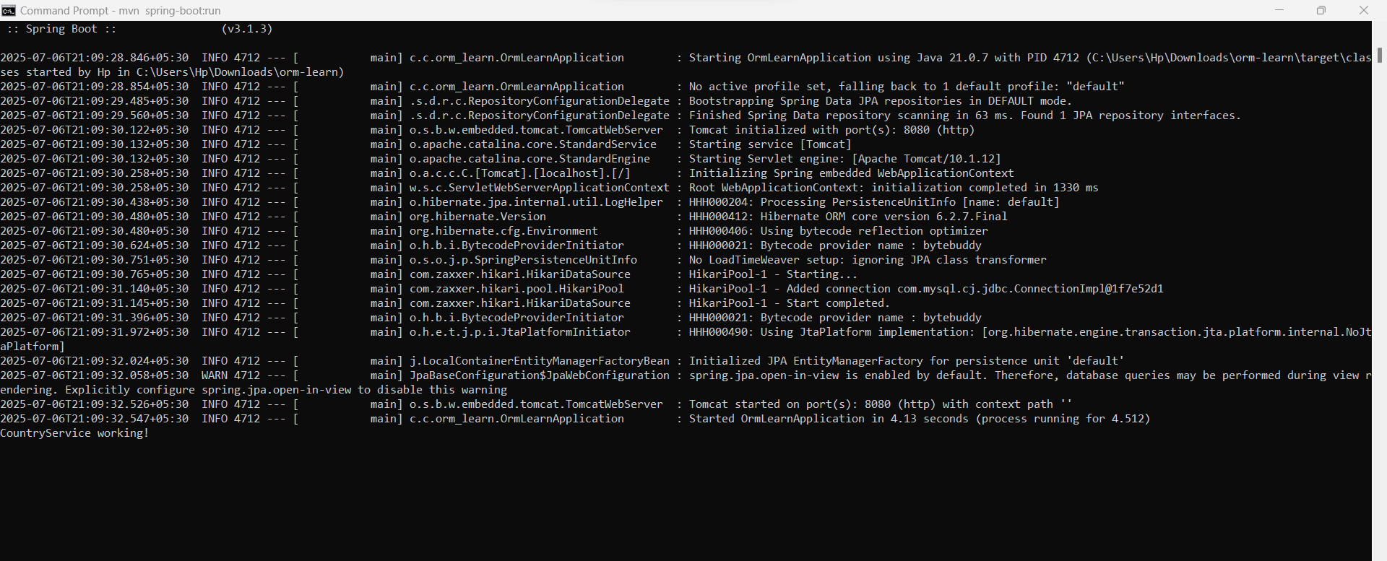

=====================================================================
Difference between JPA, Hibernate and Spring Data JPA
MySpringDataJpaApp.java:
package com.example;

import org.springframework.boot.SpringApplication;
import org.springframework.boot.autoconfigure.SpringBootApplication;

@SpringBootApplication
public class MySpringDataJpaApp {
public static void main(String[] args) {
SpringApplication.run(MySpringDataJpaApp.class, args);
}
}

EmployeeController.java:
package com.example.controller;

import com.example.model.Employee;
import com.example.service.EmployeeService;
import org.springframework.beans.factory.annotation.Autowired;
import org.springframework.web.bind.annotation.*;

@RestController
@RequestMapping("/employees")
public class EmployeeController {
@Autowired
private EmployeeService employeeService;

@PostMapping
public Employee addEmployee(@RequestBody Employee employee) {
return employeeService.addEmployee(employee);
}

@GetMapping("/{id}")
public Employee getEmployee(@PathVariable Integer id) {
return employeeService.getEmployeeById(id);
}
}
Employee.java:
package com.example.model;

import javax.persistence.Entity;
import javax.persistence.GeneratedValue;
import javax.persistence.GenerationType;
import javax.persistence.Id;

@Entity
public class Employee {
@Id
@GeneratedValue(strategy = GenerationType.IDENTITY)
private Integer id;

private String name;
private String department;

}
EmployeeRepository.java:
package com.example.repository;

import com.example.model.Employee;
import org.springframework.data.jpa.repository.JpaRepository;

public interface EmployeeRepository extends JpaRepository<Employee, Integer> {
}
EmployeeService.java:
package com.example.service;

import com.example.model.Employee;
import com.example.repository.EmployeeRepository;
import org.springframework.beans.factory.annotation.Autowired;
import org.springframework.stereotype.Service;

@Service
public class EmployeeService {
@Autowired
private EmployeeRepository employeeRepository;

public Employee addEmployee(Employee employee) {
return employeeRepository.save(employee);
}

public Employee getEmployeeById(Integer id) {
return employeeRepository.findById(id).orElse(null);
}
}

OUTPUT:




